CHAPTER 1

# Classification of Data:

1. Qualitative [Inherently Discrete]:
   1. Normal: No natural order between the categories. (eg. eye color)
   2. Ordinal: If there is a natural order between the categories. (eg. socio-economic status)
2. Quantitative:
   1. Discrete: Measurements are integers.
   2. Continuous: Measurements can take up any value, usually within a range.

# Presenting Discrete Data:

1. Frequency Distribution Tables:

DATA

FREQUENCY

REL. FREQUENCY (Freq/Total Freq)

%age FREQUENCY (Rel. Freq * 100%)

1. Bar Charts:

* Gaps between rectangles for discrete data.

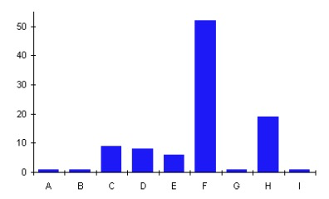

# Presenting Continuous Data:

1. Frequency Distribution Tables:

* Choose a set of continuous, non-overlapping class intervals.
  + [a, b) = Inclusive of a but not b.
* Make a table similar to the one for discrete data.

1. Histograms:

* Bar charts without gaps between rectangles.
* Area of Rectangle $∝$ Frequency i.e. Height $∝$ Frequency if Class Widths are same.

1. Dot Plots:

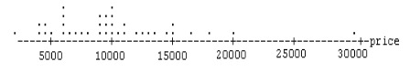

# Measures of Central Location:

1. Mode
   1. Data value with the highest frequency. 1 Mode = Unimodal, 2 Modes = Bimodal.
   2. For grouped data, the mode is the midpoint of the class with the highest frequency.
2. Median
   1. Positional Middle Value
   2. For grouped data:

$$\tilde{x}=L+\left(\frac{j}{f} × c\right)$$

where $L$ = Lower Boundary of Median Class

$j$ = No. of Items needed to reach Median Value.

$f$ = Frequency of Median Class

$c$ = Class Width of Median Class

1. Mean
   1. Arithmetic average of all the data values.
   2. For grouped data:

$$\overline{x}=\frac{\sum{x_{i}f_{i}}}{\sum{f_{i}}}$$

where $x_{i}$ = Midpoint of Class

* Symmetric Unimodal Distribution 🡪 Mode = Median = Mean

# Measures of Variation

1. Range = Maximum Value – Minimum Value
2. Quartiles:
   1. $Q_{2}$ = Median
   2. If n is odd:
 $$Q_{1}=Median of First \frac{n-1}{2} values$$

 $$Q_{3}=Median of Last \frac{n-1}{2} values$$

 3. If n is even:
 $$Q_{1}=Median of First \frac{n}{2} values$$

 $$Q_{3}=Median of Last \frac{n}{2} values$$

 $IQR=Q_{3}-Q_{1}$

4. Box Plots:

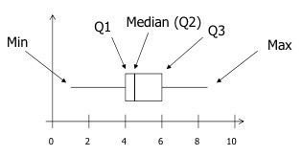

1. Standard Deviation & Variance
   1. S.D. = Average Distance of Data Values from Mean

$$σ=\sqrt{\frac{\sum{{\left(x_{i}-\overline{x}\right)}^{2}}}{n}}$$

$$s= \sqrt{\frac{\sum{{\left(x_{i}-\overline{x}\right)}^{2}}}{n-1}}=\sqrt{\frac{1}{n-1}\left[\sum{{x_{i}}^{2}}-\frac{{\left(\sum{x_{i}}\right)}^{2}}{n}\right]}$$

$s$ is an unbiased estimator of $σ$.

For grouped data:

$$s= \sqrt{\frac{1}{\sum{f_{i}}-1}\left[\sum{{f_{i}x_{i}}^{2}}-\frac{{\left(\sum{f_{i}x_{i}}\right)}^{2}}{\sum{f_{i}}}\right]}$$

CHAPTER 2

* A sample space is the set of all the possible outcomes of an experiment.
* An event is a set of one or more outcomes from the sample space.
* Two events are **mutually exclusive** if they have no outcomes in common.
* Events are **exhaustive** if they cover all possible outcomes.
$$P\left(A\right)=\frac{\# of outcomes corresponding to A}{Total \# of outcomes in sample space}=\frac{f\left(A\right)}{n}$$

$$0≤P\left(A\right)≤1$$

* Mutually Exclusive Events, $A$ and $B$:
$P\left(A and B\right)= 0$

$P\left(A | B\right)=0$

$P\left(A or B\right)= P\left(A\right)+ P(B)$

* Non-Mutually Exclusive Events:
$P\left(A or B\right)= P\left(A\right)+ P(B)-P(A and B)$

* Independent Events:
$P\left(A and B\right)= P\left(A\right) P(B)$

$P\left(A | B\right)=P(A)$

* Dependent Events:

$$P\left(X | Y\right)=\frac{P\left(X and Y\right)}{P\left(Y\right)}$$

$$P\left(X | Y\right)=\frac{P\left(Y | X\right) P\left(X\right)}{P\left(Y\right)} \left[{Bayes}^{'} Theorem\right]$$

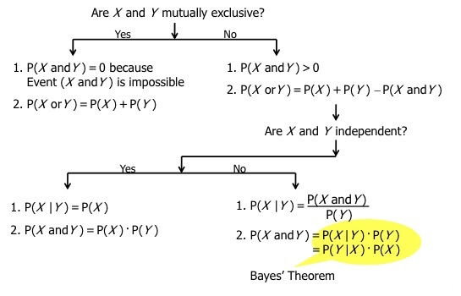

CHAPTER 3

# Random Variables

* A random variable is a variable that has a numerical value determined by the outcomes or events of an experiment.
* A random variable can be discrete or continuous.

**For an R.V $X$:**

|  |  |  |  |  |  |
| --- | --- | --- | --- | --- | --- |
| $$x$$ | $$x_{1}$$ | $$x_{2}$$ | $$x_{3}$$ | $…$… | $$x_{i}$$ |
| $$P(X=x)$$ | $$p_{1}$$ | $$p_{2}$$ | $$p_{3}$$ | $…$… | $$p_{i}$$ |

$$E\left(X\right)= \sum{p_{i}x_{i}}$$

$$var\left(X\right)= \sum{p_{i}}{\left(x_{i}-μ\right)}^{2}=E\left[{\left(x-μ\right)}^{2}\right]=E\left(X^{2}\right)-μ^{2}$$

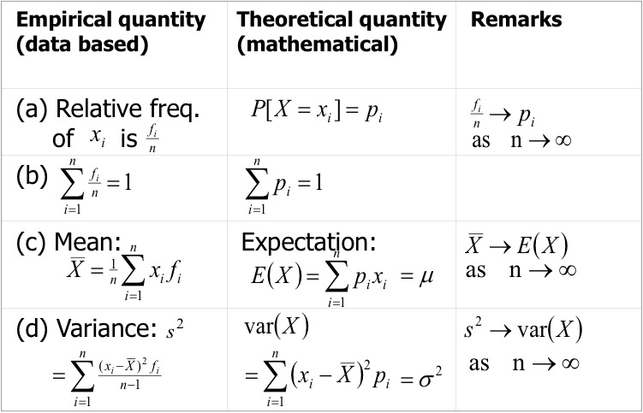

**For $Y=a+bX$:**

$$E\left(Y\right)=a+bE\left(X\right)$$

$$var\left(Y\right)=b^{2} var\left(X\right)$$

$$σ_{Y}=b σ_{X}$$

**For $T=a+bX+cY$:**

$$E\left(T\right)=a+bE\left(X\right)+cE\left(Y\right)$$

$$var\left(T\right)=b^{2} var\left(X\right)+ c^{2} var\left(X\right)+ 2bc cov\left(X,Y\right)$$

$$var\left(T\right)=b^{2} var\left(X\right)+ c^{2} var\left(X\right)$$

when $cov\left(X, Y\right)= 0$ if $X$ and $Y$ are independent.

# Binomial Distribution

1. n Bernoulli Trials – where each trial has exactly two possible outcomes.
2. Probability of success/failure is same for all trials.
3. All trials are independent. Probability of any given combination of successes & failures can be obtained by multiplying the probabilities of every outcome.

**Combining 5 Trials:**

$P\left(SSFSF\right)= p^{3}{\left(1-p\right)}^{2}$ where $p=P(S)$

* However, there are many ways to get three Ss & two Fs in 5 trials. For example, SSSFF, SSFFS etc.
* The number of distinct arrangements is given by the binomial coefficient ${}_{}^{n}{C_{r}}$ where *n* is the no. of trials & *r* is the no. of required successes.

**Random Variable:**

Let $X$ be the R.V equal to the total no. of successes in *n* trials. To calculate the probability of obtaining $x$ successes,

$$P\left(X=x\right)={{}_{}^{n}C}_{x} × p^{x} × {\left(1-p\right)}^{n-x}$$

$$X \sim B(n, p)$$

# Continuous Distribution

**Probability Density Function:**

1. 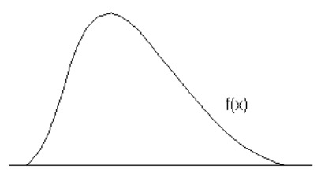 $f\left(X\right)≥0$ for all $X$
$P\left(a<X<b\right)=\int_{a}^{b}{f\left(X\right) dX}$

2. Total Area Under Curve $=$ 1

* $P(X<x)$ is known as the CDF of $X$.
* $P\left(X=x\right)=0$ for a continuous RV.

$$E\left(X\right)=\int_{-∞}^{∞}{x f(x)} dx=μ$$

$$var\left(X\right)=\int_{-∞}^{∞}{{\left(x-μ\right)}^{2} f\left(x\right) dx=E\left(X^{2}\right)-E{\left(X\right)}^{2}}$$

$$where E\left(X^{2}\right)= \int_{-∞}^{∞}{x^{2} f\left(x\right) dx}$$

# Uniform Distribution

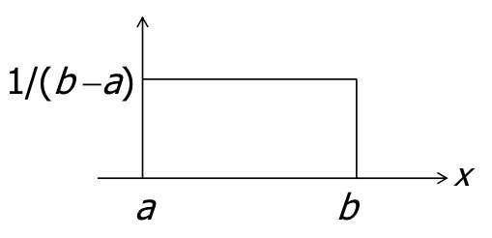

$$X \sim U(a, b)$$

* $X$ can take any real value between $a$& $b$ with uniform probability
* Thus, the PDF is $f\left(x\right)=\frac{1}{b-a}$ for $a≤X≤b$.
* For any value $c$& $d$ between $a$& $b$:

$$P\left(c<X<d\right)=\frac{1}{b-a}(d-c)$$

**Normal Distribution**

$$f\left(X\right)=\frac{1}{σ\sqrt{2π}}e^{-\frac{1}{2}{\left(\frac{X-μ}{σ}\right)}^{2}} for -∞<X<∞$$

$$X \sim N\left(μ, σ^{2}\right)$$

**Standard Normal Distribution**

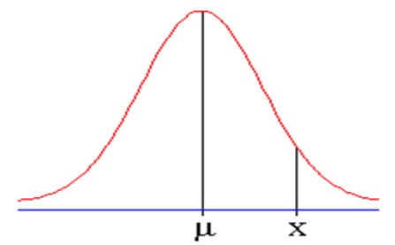 $Z \sim N(0, 1)$

$$E\left(Z\right)=0$$

$$var\left(Z\right)= 1$$

$$X=μ+Zσ$$

$$Z=\frac{X-μ}{σ}$$

**Normal Approximation to Binomial Distribution**

* For large *n* or *p $≈$* 0.5 or *np* > 5 & *n(1 – p)* > 5, binomial distribution approximately follows normal distribution.
* For $X \sim B(n, p)$ when the conditions above are followed,
 $E\left(X\right)=μ=np$

 $var\left(X\right)=σ^{2}=np(1-p)$

+ So,

$$Z=\frac{X-np}{\sqrt{np\left(1-p\right)}} is approximately N(0, 1)$$

**Continuity Correction & Accuracy**

Since it’s a discrete R.V approximated to a continuous R.V, continuity correction is needed.

For example, $X=2$:

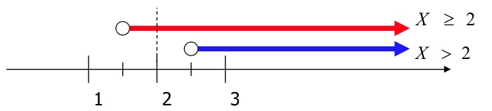

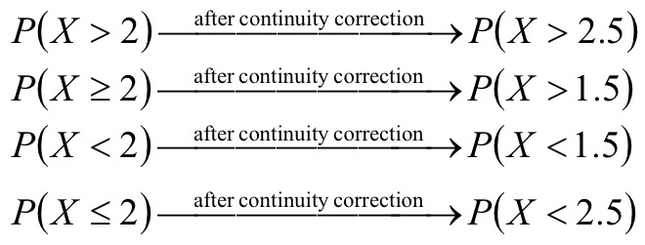

CHAPTER 4

**Population VS Sample**

* A population is a collection of all the subjects or objects of interest whereas a sample is a subset of the population used to estimate the characteristics of the population.
* A population parameter is a numerical characteristic of a population such as the mean, standard deviation, variance etc.
* A sample statistic is a numerical characteristic of a sample that can be used to estimate the corresponding population parameter.

**Sampling Distribution**

* Suppose we take many different samples and calculate the sample statistic for each (eg. Mean: ${\overline{X}}_{1}$, ${\overline{X}}_{2}$, ${\overline{X}}_{3}$…… ${\overline{X}}_{n}$), we can then draw a histogram for these sample statistics. Such sample statistics can be regarded as a R.V and the histogram is an approximation to its sampling distribution.
* Central Limit Theorem: As the number of samples, *n $→$ $∞$* , the distribution of the sample mean $\overline{X}$ approaches a normal distribution with the following characteristics:

$$E\left(\overline{X}\right)=μ$$

$$var\left(\overline{X}\right)=\frac{σ^{2}}{n}$$

$$Standard Error=\sqrt{var\left(\overline{X}\right)}=\frac{σ}{\sqrt{n}}$$

$$var\left(\overline{X}\right)∝\frac{1}{n}$$

$$\overline{X} \sim N\left(μ,\frac{σ^{2}}{n}\right)$$

**Confidence Intervals**

* The sample mean provides a point estimate for $μ$ whereas confidence intervals provide an interval estimate together with a degree of confidence that the parameter is in that interval.

**Example – 95% Confidence Interval:**

$$\overline{X} \sim N\left(μ,\frac{σ^{2}}{n}\right)$$

$$Z=\frac{\left(\overline{X}-μ\right)}{\frac{σ}{\sqrt{n}}} where Z \sim N\left(0, 1\right)$$

Now, we need to create a symmetric interval $(-a, a)$ such that $P\left(-a<Z<a\right)=0.95$.

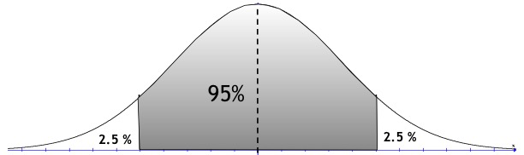

$- a$ $0$ $a$

$$P\left(Z>a\right)=P\left(Z<-a\right)=0.025$$

$$∴P\left(Z<a\right)=0.95+0.025=0.975$$

$$∴a=invnorm\left(0.975\right)=1.96$$

$$∴P\left(-1.96<\frac{\overline{X}-μ}{\frac{σ}{\sqrt{n}}}<1.96\right)=0.95$$

$$∴P\left(\overline{X}-1.96\frac{σ}{\sqrt{n}}<μ<\overline{X}+1.96\frac{σ}{\sqrt{n}}\right)=0.95$$

* Increasing the sample size increases the precision of the estimate by $\frac{1}{\sqrt{n}}$ since the width of the interval decreases.

**Hypothesis Testing**

* To test a hypothesis that a population parameter has some specified value, two approaches can be used.

**Confidence Interval Approach**

1. Calculate the confidence interval.
2. Check if H0 (Null Hypothesis) is consistent with the interval.
3. If it is not, H0 is rejected and HA (Alternate Hypothesis) is accepted.

**p-Value Approach**

**Q:** A manufacturer produces bolts with a said mean length of 15 cm and $σ=$ 0.3 cm. A sample of 50 bolts has a mean length $\overline{X}=$ 14.85 cm. Does this suggest, with 0.05 significance level, that the average length of all the bolts is not 15 cm?

1. **Define H0 and HA.**
2. **Specify the significance level. $(α)$**
$$α=0.05$$

3. **Calculate the probability of getting a sample $\overline{X}$ as far away from the assumed population mean as was observed.**

Observation: $\overline{X}=14.85 cm$

Thus, $P\left( \overline{X}≤14.85 or \overline{X}≥15.15\right)$ needs to be found. This is the *p-value*.

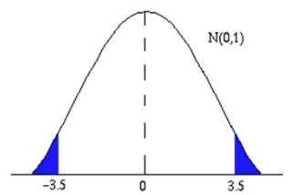 $X \sim N\left(15,\frac{{0.3}^{2}}{50}\right)$

$$z=\frac{\overline{X}-15}{\frac{0.3}{\sqrt{50}}}$$

Hence,

$$P\left( \overline{X}≤14.85 or \overline{X}≥15.15\right)=P(z≤-3.5 or z≥3.5)$$

$=0.002$

1. **Compare the p-value with $α$ in order to accept or reject H0. If p-value $≤$ $α$, there is sufficient evidence to reject H0. Else, there is insufficient evidence to reject H0, thus, it is accepted.**

**Null Hypothesis VS Alternate Hypothesis**

* H0 (Null Hypothesis) can be either:
$μ=a$

$μ≥a$

$μ≤a$

* In contrast, HA refers to the other possible values of the population parameter. It is true if H0 is not.
* HA (Alternate Hypothesis) can be either:

$μ≠a$

$μ≤a$

$μ≥a$

**Errors**

* Type I Error: H0 is true but it is rejected.
* Type II Error: HA is true but H0 is accepted.

**Tests Concerning Means**

* If the population variance is known and sample size ($n$) is anything:
$$z=\frac{\overline{X}-μ}{\frac{σ}{\sqrt{n}}}$$

* If the population variance is unknown and $n≥30$:
$$z=\frac{\overline{X}-μ}{\frac{s}{\sqrt{n}}}$$

* If the population variance is unknown and $n<30$:

$$t=\frac{\overline{X}-μ}{\frac{s}{\sqrt{n}}}$$

i.e. We use the tr-distribution with $(n-1)$ degrees of freedom $(r)$.

$$r=n-1$$

As $r→∞$, tr-distribution $→N(0, 1)$.

**Tests Concerning Proportions**

* Suppose we are interested in a population where each individual can be classified into one of two categories. For example: Pass/Fail, True/False, OK/Defective etc.
* In general, they are called successes and failures.
* We want to arrive at conclusions about $p$, the proportion of successes in the population, using information from a sample.

Let a R.V $X$ be the number of successes in a random sample of $n$ ­ individuals:

$$X \sim B(n, p)$$

$$\hat{p}=\frac{X}{n} where \hat{p} is the proportion of successes$$

If $X \sim B(n, p)$, we have $E\left(X\right)=np$ and $var\left(X\right)=npq$. Therefore,

$$E\left(\hat{p}\right)=\frac{1}{n}E\left(X\right)=\frac{np}{n}=p$$

$$var\left(\hat{p}\right)=\frac{1}{n^{2}}var\left(X\right)=\frac{npq}{n^{2}}=\frac{pq}{n}$$

$$SD\left(\hat{p}\right)=\sqrt{\frac{pq}{n}}$$

If $np>5$ and $n\left(1-p\right)>5$, $X \sim B(n, p)$ can be approximated to:

$$\hat{p} \sim N\left(p,\frac{pq}{n}\right)$$

Thus, we can use $z$ to make inferences about the population parameter, $p$.

$$z=\frac{\hat{p}-p}{SD\left(\hat{p}\right)}$$

**Small Samples**

* When $n$ is small, we cannot approximate the distribution of $X$ to a normal distribution. Thus, we will base our test directly on the evaluation of the binomial probabilities.

**Q:** In USA, six of the seven first IVF babies were girls. Did IVF somehow affect the sex of the babies?

$$H_{0}:P\left(G\right)=0.5$$

$$H_{A}:P\left(G\right)≠0.5$$

$$α=0.05$$

$$Test Statistic is no. of girls:X=6$$

$$p=2 × P\left(X≥6\right)=2 × P\left(X=6 or X=7\right)=0.125$$

Since $0.125>0.05, H_{0}$ cannot be rejected. Hence, $P\left(G\right)=0.5$.